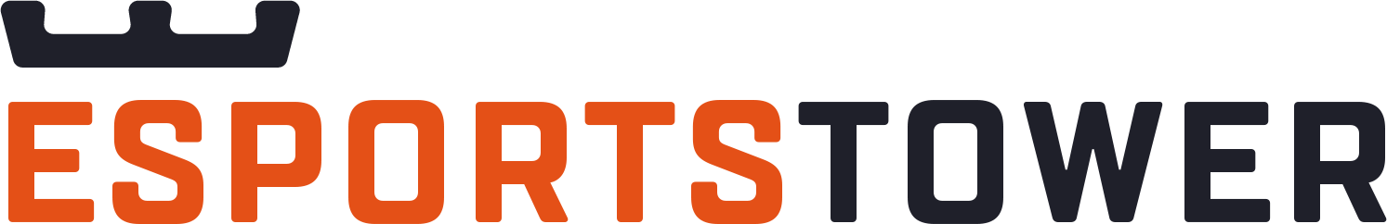 CAREER GOALS WORKSHEET

PRIMARY CAREER INTEREST
LONG-TERM PROFESSIONAL GOALS
SHORT-TERM PROFESSIONAL GOALS
ACTIVITIES TO REACH GOALS
CURRENT TASKS THAT CONTRIBUTE TO LONG-TERM GOALS
How can these tasks be emphasized and performed more frequently?
CURRENT TASKS THAT DO NOT CONTRIBUTE TO LONG-TERM GOALS
How can these tasks be minimized or eliminated / delegated?
ADDITIONAL SKILLS / KNOWLEDGE / EXPERIENCE NEEDED TO ATTAIN GOALS
PROGRESS CHECKPOINTS & TASKS
What activities will contribute to reaching goals, and how / when will they be completed and monitored?

DISCLAIMER

Any articles, templates, or information provided by Esports Tower on the website are for reference only. While we strive to keep the information up to date and correct, we make no representations or warranties of any kind, express or implied, about the completeness, accuracy, reliability, suitability, or availability with respect to the website or the information, articles, templates, or related graphics contained on the website. Any reliance you place on such information is therefore strictly at your own risk.
This material is intended for individual use only.
© Esports Tower LLC - All rights reserved.

